Thank you to our new sponsors!

Materials Transfer Services, LLC

The company operates 12 power unit(s) and 9 driver(s). The company has been registered US DOT since 04-JAN-07

MATERIALS TRANSFER SERVICES LLC

telephone: (541) 321-2369

fax: (541) 998-3729

[materialstransferservicesllc@yahoo.com](mailto:materialstransferservicesllc@yahoo.com) .

94879 HWY 99W  
JUNCTION CITY  
OR  
97448  
US

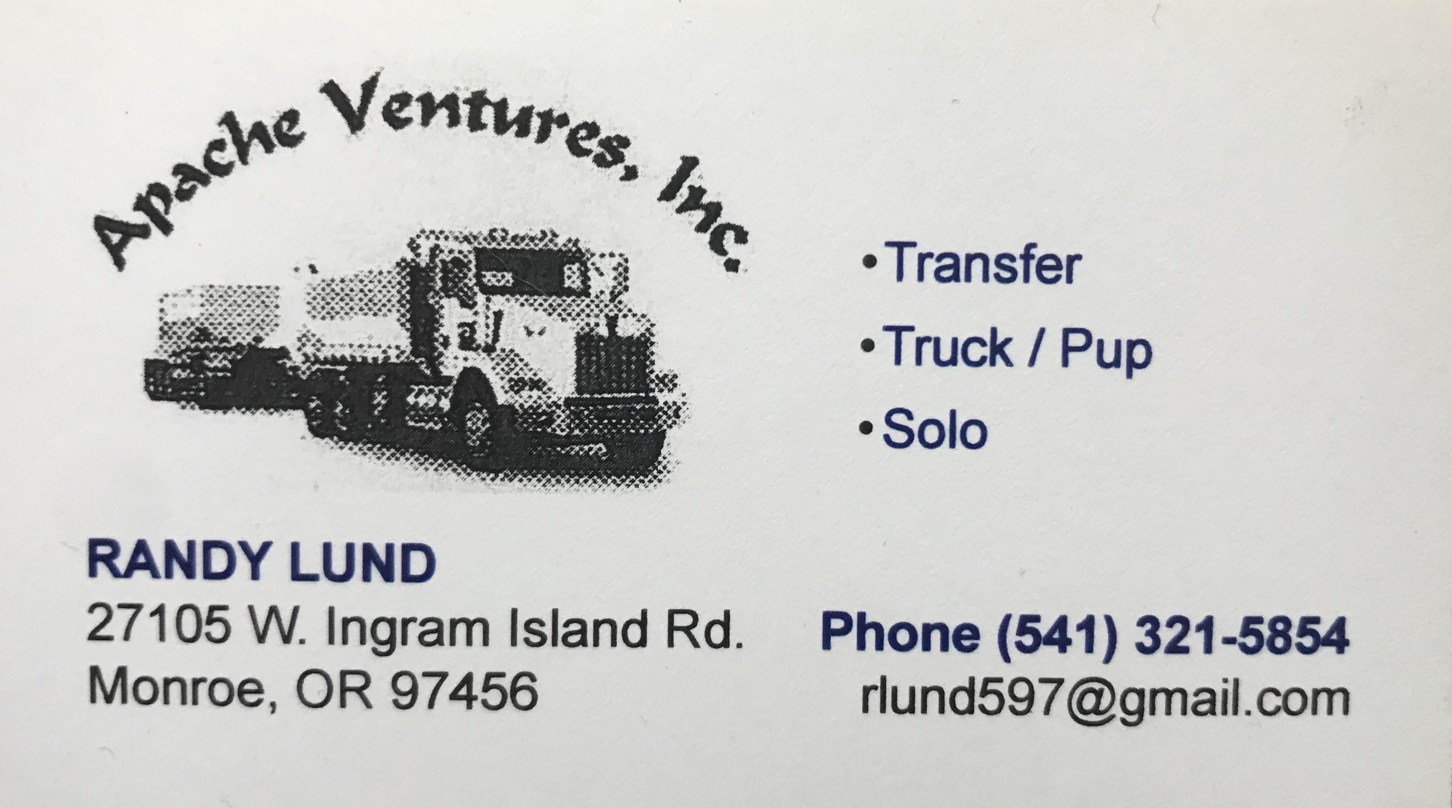

Apache Ventures,, Inc..   
27105 W Ingram Island Rd  
Monroe, OR 97456-9639  
  
*Mailing Address:*  
Po Box 185  
Monroe, OR 97456-0185  
 [541-968-4545](tel:5419684545)  
 [541-550-2299](fax:5419684545)

Apache Ventures,, Inc.. is an active DOT registered motor operating under USDOT Number 2870289.

|  |  |
| --- | --- |
| **Total Trucks** | 6 |
| **Tractors Owned** | 2 |
| **Trailer Owned** | 2 |
| **Total Drivers** | 6 |